**FIRE DETECTION AND LOCALISATION**

**A PROJECT REPORT**

###### **Submitted by**

##### **Ayushree Ghoshal (19BAI10022)**

**Jigyasa Bisht (19BAI10025)**

**Vanshika Sabhani (19BAI10054)**

**Rashmi Rawat (19BAI10077)**

*in partial fulfillment for the award of the degree*

*of*

**BACHELOR OF TECHNOLOGY**

*in*

# **COMPUTER SCIENCE AND ENGINEERING**

*Specialization in*

***Artificial intelligence and machine learning***



**SCHOOL OF COMPUTING SCIENCE AND ENGINEERING**

**VIT BHOPAL UNIVERSITY**

**KOTHRIKALAN, SEHORE**

**MADHYA PRADESH - 466114**

##### MAY 2021

**VIT BHOPAL UNIVERSITY,KOTHRIKALAN, SEHORE**

**MADHYA PRADESH – 466114**

**BONAFIDE CERTIFICATE**

Certified that this project report titled **“FIRE DETECTION AND LOCALISATION”** is the bonafide work of “**AYUSHREE GHOSHAL (19BAI10022), JIGYASA BISHT (19BAI10025), VANSHIKA SABHANI (19BAI10054)** and **RASHMI RAWAT (19BAI10077)”** who carried out the project work under my supervision. Certified further that to the best of my knowledge the work reported here does not form part of any other project / research work on the basis of which a degree or award was conferred on an earlier occasion on this or any other candidate.

**PROGRAM CHAIR PROJECT GUIDE**

Dr. S Sountharajjan Dr. Durga Prasad

Senior Assistant Professor Senior Assistant Professor

School of AI & ML division School of AI & ML division

VIT BHOPAL UNIVERSITY VIT BHOPAL UNIVERSITY

The Project Exhibition II Examination is held on **4th MAY 2021.**

**ACKNOWLEDGEMENT**

First and foremost, We would like to thank the Lord Almighty for his presence and immense blessings throughout the project work.

We wish to express my heartfelt gratitude to **Dr. Manas Kumar Mishra**, Dean, School of Computer Science for much of his valuable support and encouragement in carrying out this work.

We would like to thank my internal guide **Dr. Durga Prasad,** for continually guiding and actively participating in my project, giving valuable suggestions to complete the project work.

We would like to thank all the technical and teaching staff of the **School of Computer Science,** who extended directly or indirectly all support.

Last, but not the least, we are deeply indebted to our **parents** who have been the greatest support while I worked day and night for the project to make it a success.

**LIST OF ABBREVIATIONS**

|  |  |  |
| --- | --- | --- |
| **S.NO** | **SHORT FORM** | **FULL FORM** |
| 1. | CNN | Convolutional Neural Network |
| 2. | YCbCr | Green(Y) , Blue(Cb), Red (Cr) (digital video color space) |
| 3. | RGB | Red Green Blue |
| 4. | HSI | Hue Saturation Intensity |
| 5. | YUV | Luminance (Y), blue–luminance (U), red–luminance (V) |
| 6. | ReLU | Rectified Linear Unit |
| 7. | LPG | Liquefied Petroleum Gases |
| 8. | GPU | Graphics Processing Unit |
| 9. | RMSProp | Root Mean Square Propagation |

**LIST OF FIGURES**

|  |  |  |
| --- | --- | --- |
| FIGURE NO. | TITLE | PAGE NO |
| 4.3.2.2 | Snap of the raw data preprocessing stage. | 20 |
| 4.3.3.1 | (a&b) snap of the CNN phase and | 21 |
| 4.3.4.1 | snap of importing the InceptionV3 model and other CNN layers | 23 |
| 4.3.4.2 | snap of the creation of the models | 24 |
| 4.3.4.3 | snap of the call back function | 24 |

**LIST OF TABLES**

|  |  |  |
| --- | --- | --- |
| **TABLE NO.** | **TITLE** | **PAGE NO.** |
| 4.3.3.1(b) | The table of the various layers. | 21 |
| 5.1 | Comparative analysis of the two models | 26-27 |

**ABSTRACT**

Fire outbreak is a common issue happening everywhere in the world. It represents a real threat to human lives, ecological systems, and infrastructure. Therefore, Fire Detection is valuable. An Early Fire Detection would warn us and a big disaster can be averted. The project aims to develop an efficient fire detection system that comes as a warning to reduce the losses caused by hazardous fire.

Vision-based fire detection approaches provide better accuracy than Traditional Fire Detection techniques. But in image processing techniques (based on open CV), the rate of false alarm is high as detection of fire is not accurate. Sometimes the yellow cloth and sunlight are detected as fire due to the same color.

So for proper detection of fire, we have proposed a Fire Detection technique that is based on powerful machine learning and deep learning algorithms. We have used CNN and the Inception V3 model to detect fire. There are approx. 1200 images out of which approx. 980 images are a part of the training set and 239 for validation. The model is trained by applying various convolution, MaxPooling, dense and dropout layers. The accuracy comes out to be 96.6% and hence the model is fit to serve the purpose of fire detection and can yield optimal results.

**TABLE OF CONTENTS**

|  |  |  |
| --- | --- | --- |
| **CHAPTER NO.** | **TITLE** | **PAGE NO.** |
|  | List of Abbreviations  List of Figures  List of Tables  Abstract | 3  4  5  6 |
| 1 | **INTRODUCTION** Brief Description 1.2 Motivation for the work  1.3 Problem Statement  1.4 Objective of the work  1.5 Summary | 9-10  . |
| 2 | **LITERATURE SURVEY**  2.1 Introduction  2.2 Existing Algorithms  2.3.1 Smoke Detectors  2.3.2 Heat Detectors  2.3.3 Fire detection in video sequences using generic color model  2.3 Observations from literature Survey | 11-13 |
| 3 | **EXISTING SYSTEM ANALYSIS**  3.1 Introduction  3.2 Limitations in the existing system  3.2.1 Heat Detectors  3.2.2 Smoke Detectors  3.3.3 Fire detection in video sequences using generic color model | 14-15 |
| 4 | **PROPOSED METHODOLOGY AND SYSTEM IMPLEMENTATION**  4.1 Introduction  4.2 Proposed Work and methodology  4.2.1 CNN Architecture  4.2.2 Inception V3  4.3 System Implementation  4.3.1 Libraries Required  4.3.2 Raw Data Preprocessing  4.3.3 Creation of the CNN Architecture  4.3.4 Creation of InceptionV3 Model | 16-25 |
| 5 | **COMPARATIVE STUDY OF OBSERVATION**  5.1 Comparative Study of the results | 26-27 |
| 6 | **FUTURE WORK AND CONCLUSION**  6.1Introduction  6.2 Future Scope and Limitations  6.3 Conclusion | 28-29 |
| 7 | **REFERENCES** | 30 |

**CHAPTER 1 INTRODUCTION**

**1.1 BRIEF DESCRIPTION**

Fire can be considered an unfortunate phenomenon that can cause catastrophic damage to property and environment. It can also pose an immense threat to human safety and lives, especially when this hazard gets out of control. A large destructive fire that spreads over a large area leads to damage to humans, environment, property and animals too. Homes can be destroyed. Forest fires are usually detected late and cause great harm to animals and the environment. Due to power failure, accidental fire, natural lightning, thousands of accidents related to fire happen all over the world yearly. Due to urbanization, more and more buildings appear around us which will cause damage to life and property if caught fire. Thus, demanding the need of fire detection.

**1.2 MOTIVATION OF THE PROJECT**

Fire is the greatest evil happening in the world today. Motivation of the project comes from the deadliest fire accidents that happened in the past.

* More than 1 lakh people lost their lives due to fire accidents from 2010 to 2014 in India.
* 1,193 persons injured and 17,700 killed in India 2015 due to various fire calamities.
* Australian wildfires of 2019-2020 were the deadliest forest fires. Half a billion animals killed, 20 million acres burnt and 100 million $ were the damage.
* On September 11, 2001, The World Trade Center in New York caught fire which led to the death of 2666 people.
* The deadliest fire in the history of California in 2018 burned 153,336 acres of land, destroyed 19000 homes and killed around 85 people.

All these incidents have posed a threat to mankind and in order to address this serious issue we seek the motivation of designing our project.

**1.3 PROBLEM STATEMENT**

Many places accidently catch fire and cause a lot of damage to human life and property. Sometimes people remain unaware of it which results in loss of lives or property. When fire breaks out, especially in an open space, it often remains undetected by the conventional smoke sensor-based detection systems until it reaches a severe stage. Therefore, skillfully designed fire detection systems can be the key to ascertain fire and provide early warning signals to work for the welfare of mankind.

**1.4 OBJECTIVE OF THE PROJECT**

The objective of the project is to design and implement a fire detection system which detects fire using Machine Learning and Deep Learning techniques.

**1.5 SUMMARY**

Fire is an unpredictable disaster that once spread gets out of control. It causes a huge loss to life and property. Specifically, forest fires pose a great threat to wildlife and the environment. To reduce the losses caused by hazardous fire, we have proposed a system which detects fire in real time through cameras.

**CHAPTER 2: LITERATURE SURVEY**

**2.1 INTRODUCTION**

The Fire Detection is a system which is implemented in houses, hotels, buildings to detect fire or smoke in case of fire outbreak. There have been several attempts to develop a model in the past to detect fire using various approaches and algorithms. Smoke detection and Heat detectors are some of them but due to certain faults and inefficiency they have not gained widespread recognition and have not been universally accepted as Efficient Fire Detectors. In this chapter we have discussed the previously existing works and pointed out the methodology as well as the Observations obtained from various models. The elaborate analysis of the faults in the existing system are carried out in the next chapter.

**2.2 EXISTING WORK**

Some of the Existing work and their respective methodology and are discussed in this unit of the chapter.

**2.2.1 HEAT DETECTORS**

A heat detector is a fire and heat detecting device which possesses mechanical or electrical operation. They are designed to trigger alarms and notification systems are designed to notify before fire or smoke becomes a dangerous factor.

**Conventional and intelligent heat detectors:** These detectors are set to alarm at the time when ambient temperatures reach a fixed point, which are set for indicating fire. The cost of fixed-temperature heat detectors is very high.

Fixed temperature spot-type detectors contain a bimetallic switch which is made of two metals at some specified temperature limit and having different temperature coefficient of expansion. The bimetallic elements warm up the metal. The higher coefficient of expansion helps the metal to cause the switch to bend and closes the switch, which will further indicate an alarm condition. When heat builds a certain level the insulation melts which allows the wires to touch and current to flow, initiating an alarm.

**2.2.2 SMOKE DETECTORS**

Smoke detectors work by one or more batteries and also some smoke detectors are connected directly to a wiring. Most of the smoke detectors have its main wiring system directly connected and also have a battery backup as power supply.

Smoke detectors **work by using optical detection or by ionization**. These methods are used to increase sensitivity to smoke. Smoke detectors can be operated alone or can be interconnected to cause the sound of an alarm in an area. And when the alarm is triggered, it is aware of the security near it. Smoke detectors with flashing lights are also available for those who cannot hear the alarm or are far from the area. These devicescannot detect carbon monoxide.

Ionization chamber smoke detectors (ICSD) also known as Ionization detectors. These can quickly sense the flaming fires that produce little smoke. This device uses a radioactive material which ionizes the air in a sensing chamber. The alarm is triggered by the presence of smoke which flows off the ions between a pair of electrodes. In American houses there are 80% of smoke detectors are ionization detectors as these are less expensive then the optical ones. The residential models can be operated on 9-V batteries.

**2.2.3 FIRE DETECTION IN VIDEO SEQUENCES USING GENERIC COLOR MODEL**

In this method a generic color model for flame pixel classification was proposed. Their algorithm used a **YCbCr color space** to separate the light from the chrominance more progressively than other color spaces such as RGB or rgb. Their algorithm took two sets of images, an image of fire and another one with fire like regions.

**2.3 OBSERVATIONS FROM EXISTING REFERENCE PAPERS**

Below listed are the observations analyzed from existing reference papers.

* T. H. Chen (2007) used the dynamic behavior of fires using RGB and HSI color models in his work “**An early fire-detection method based on image processing**”. In this project he has proposed a decision rule for assisted fire detection approach, which uses the irregular properties of fire for detection. The approach of the project was based on frame-to-frame differences and because of that it cannot differentiate between fire and fire-colored moving regions.
* G. Marbach (2006) work “**An image processing technique for fire detection in video images**” is based on the temporal variation of fire and flame intensity, which is captured by a visual image sensor which tests the YUV color space. Here, the full image sequences are analyzed to select a flame region. It determines the presence of fire or non-fire patterns. It uses motion information technique to classify pixels into fire and non-fire components.
* B. U. Töreyin (2006) in his project “**Computer vision-based method for real-time fire and flame detection**” uses analysis techniques of temporal and spatial wavelet to determine fire and non-fire areas. Color variations in flame areas are detected by analyzing the spatial wavelet transform of moving fire-colored regions. This method reduces the false alarms issued to fire-colored moving objects as compared to the other methods using only motion and color clues in it. Their project used many heuristic thresholds, which greatly restricts its real-world implementation.
* D. Han and B. Lee (2006) work “**Development of early tunnel fire detection algorithm using image processing**” worked on to avoid large scale damage of fire occurring in a tunnel. So, they used an algorithm of image processing, which is an early fire detection of dire occurrence in the tunnel. Their project made it easy to detect the exact place of fire. It also compared normal frames with the color information for tunnel fire detection. But this method was suitable only for static fires, as it is based on various parameters.
* T. Çelik and H. Demirel (2009) work “**Fire detection in video sequences using a generic color mode**” use a rule-based generic color model for classification. They use flame pixel classification which was used to separate the light from the chrominance more effectively than RGB or rgb. This method can be used in real-time fire detection in color video patterns and presents segmentation of fire in video using color. It discovered the YCbCr color space and presents a pixel classification method for flames.

**CHAPTER 3: EXISTING SYSTEM ANALYSIS**

**3.1 INTRODUCTION**

After going through a lot of research papers, we made an analysis and came to the conclusion that the existing system has several disadvantages. A survey of existing literature shows that a model with high computation cost gives a better accuracy while the model with low computation cost has to compromise with the accuracy. Hence to address the issues we have introduced the concept of Convolutional Neural network and Inception V3 Model.

**3.2 LIMITATIONS IN EXISTING SYSTEM**

**3.2.1 HEAT DETECTORS**

**Disadvantages of the Model**

* Do not sense particles of combustion.
* Designed to alarm only when heat on their sensors increase at a predetermined rate or reaches a predetermined level.
* Heat detectors only protect property but not human life.
* Blockage of the heat flow to the detector due to objects.
* Heat detectors are generally slower to detect fires.
* Heat detectors cannot detect smolder fires which is the leading cause of death in such accidents.

**3.2.2 SMOKE DETECTORS**

**Disadvantages of the Model**

* Are plagued by false alarms.
* Cannot be used in construction, cooking, steamy, humid, dusty, sanding environments.
* Cannot detect fires that release less smoke like LPG fires.
* A combination of smoke and heat detectors is required for effective detection.
* Requires separate infrastructure for setup which is costly.

**3.2.3 FIRE DETECTION IN VIDEO SEQUENCES USING GENERIC COLOR MODEL**

**Disadvantages of the Model**

* The model predicts sunlight as fire due to the same color as fire.
* The model predicts yellow and orange colored cloth as fire.
* It detected the flame of a burned matchstick but it could not detect the flame of fire produced when a paper was burnt.
* Could not detect fire with a light-colored background.

**CHAPTER 4: PROPOSED METHODOLOGY AND SYSTEM IMPLEMENTATION**

**4.1 INTRODUCTION**

In our project, the CNN architecture we proposed to work with is inspired by AlexNet architecture. With the perfection over algorithm with time, CNN is the ideal choice for the Image Analysis and Classification project. Above all pre-processing is considerably lower in CNN compared to other classifier models.

Image can be represented as a matrix of pixel intensity values, after the flattening process, we can further process the image matrix in Multi-Level Perceptron for analysis. Through appropriate filters, we can successfully apprehend the image’s spatial and temporal dependencies. Reusability of weights and reduction of parameters ease the function of the algorithm by performing filtering image datasets on superior quality. Further considering fire dataset hyper tunning of parameters are performed.

**4.2 PROPOSED WORK AND METHODOLOGY**

**4.2.1 CNN Architecture**

The dataset contains colored images that are RGB images that consists of -three layers of the color panel – Red, Green, and Blue. The higher the quality of the image dimension the higher will be the order of the matrix. The reduction of a matrix into easier processing form is done by CNN. Kernel/Filter are involved in the convolution operation performing convolution layers first part until the whole image matrix is traversed. The convolution operation is a necessity because it performs the extraction of high-level features from the image. The first layer is not wholly responsible for all high-level features instead many added layers work together to give us the architecture which helps to adapt to high-level features further developing an understanding of images. Some of those layers would be pooling, dense, and dropout layers.

Extraction of features, dimension reduction, reducing the number of parameters is the major function performed by the pooling process. Though there several other pooling layers available but, in our project, we focus on two major pooling layer that is Max Pooling, and Average Pooling

The working of max pooling focuses on retaining the highest number of pools and the rest are discarded. The highest number of the pool helps us to extract the significant features of the image. Padding and strides help to reduce the image size in pooling. While with the help of average pooling we retain the average of the pool thus providing us with average features of the pool.

Although Dense Layer is a non-linear layer it is made up of the same formulas as those of the linear layer(ax+b), the non-linearity is introduced because of the activation function through which the end result is passed, thus by introducing a linear activation function we can make a dense layer as a linear layer. All non-linear activation functions can be degraded into the Taylor series which further produces polynomials of higher order. Stacking several dense layers creates a polynomial of a higher degree thus it means that as the number of layers is added in the model more complex mathematical function is obtained.

The major function of dropout which is nothing but a regularization technique is to prevent the model from overfitting during the training phase but this also leads to an increase in total time during training. We set the neuron to 0 which has a probability of p in dropout at each hidden layer. When a neuron is dead it doesn’t propagate in the rest of the neural net. The network is made to learn to generalize more to get the same performance as when it tried to remember things. This increases the model's capability to generalize more and hence causes the decline in the risk of overfitting.

**4.2.2 Inception V3**

Furthermore, after facing some limitations on CNN architecture we processed to go with the Inception layer working. The major advantage of Inception over other CNN architecture is the access to multiple filter sizes rather than being reduced to an exclusive filter size in an image block. This CNN is 48 layers deep which also allows us to access a pre-trained version of the network which proves to be resourceful for object classification. Training on millions of images provided by the ImageNet database has helped the network in high-quality representation of an extensive range of images.

The activation function that we have used in our project is ReLu activation, Softmax activation. Implementation of activation functions is either at the end or in between networks. The activation of a neuron is entirely decided by the activation function, the transformation of the input weighted sum to the output node is decided by the activation function.

ReLu is a linear activation function most commonly used. The output for all positive functions is identity while it’s 0 for all negative functions. There is no involvement of complicated mathematical processes thus helping the model to train in less time. Due to linearity slope, there is nil saturation in the slope plateau. Though this is also a downside for the activation function as the neuron will be “dead” if the output is negative for a prolonged time.

Softmax activation function majorly focuses to convert logits to probabilities whose sum is one. The vector output by the function demonstrates the distribution of the probability of all possible outcomes. Multi-class classification usually has loss in cross-entropy form. CNN using ImageNet usually has Softmax appended in the image classification networks at the last layer.

**4.3 SYSTEM IMPLEMENTATION**

We have divided the system into modules for better work flow explanation and for clear understanding. The unit is divided into four modules that are as follows:

* Libraries Required
* Raw Data Preprocessing
* Creation of the CNN Architecture
* Creation of InceptionV3 Model

Let us understand the modules one by one.

**4.3.1 LIBRARIES REQUIRED**

In this module we see the inclusion and significance of various neural network open-source models and libraries used.

import tensorflow as tf

Tensor flow is an open-source library for deep learning applications. It supports traditional machine learning and huge numeric computations thus open sourced by google. Data is fed in the form of a multi-dimensional array of high dimensions (TENSOR) as they can handle a huge dataset. As the mechanism of execution is mostly graphical it is much easier to execute across a cluster of computers by using GPUs.

import keras_preprocessing

from keras_preprocessing import image

from keras_preprocessing.image import ImageDataGenerator

The Keras libraries are used for data pre-processing and data augmentation. The library's help is to work with image data and resizing of the imported images of the dataset.

**4.3.2 RAW DATA PREPROCESSING**

In this module we have taken a dataset consisting of fire and non-fire images from ImageNet and performed training and validation of the images.

Below is the snippet of the code attached.

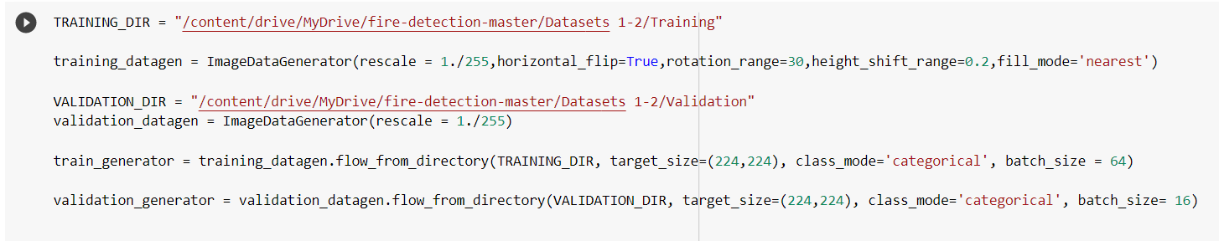

Fig4.3.2.2 snap of the raw data preprocessing stage.

We have used the ImageDataGenerator for labeling the dataset for training. We need to ensure the same size, height and rotation to enable the machine easy and hassle-free learning. We apply 3 data augmentation techniques — horizontal flipping, rotation, and height shifting.

Finally, we have kept approx 980 images for training and 239 images for validation of the function and the predictions are accurately made.

**4.3.3 CREATION OF THE CNN ARCHITECTURE**

We use an optimizer to help us to change the attributes and adjust the weights to improve the learning rate of the model. We use ADAMs optimizer instead of the classical gradient descent to update weights of the training data. ADAM has the perks of AdaGrad and RMSProp helping it to maintain the learning rate of each weight unlike the classical method where the learning rate is not stored during the training set.

We have three Conv2D, MaxPooling2D and Dense layers. To avoid overfitting Dropout layers are also added. At the last layer give the Probability distribution for both fire and non-fire.

Below is the snippet of the code and the table created.

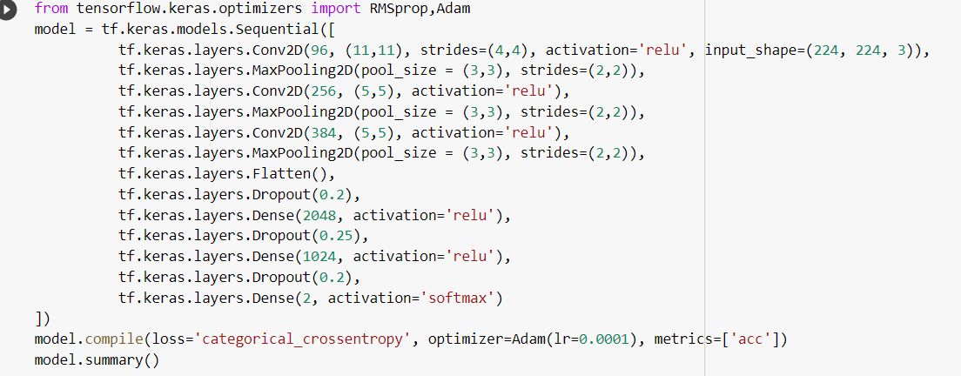

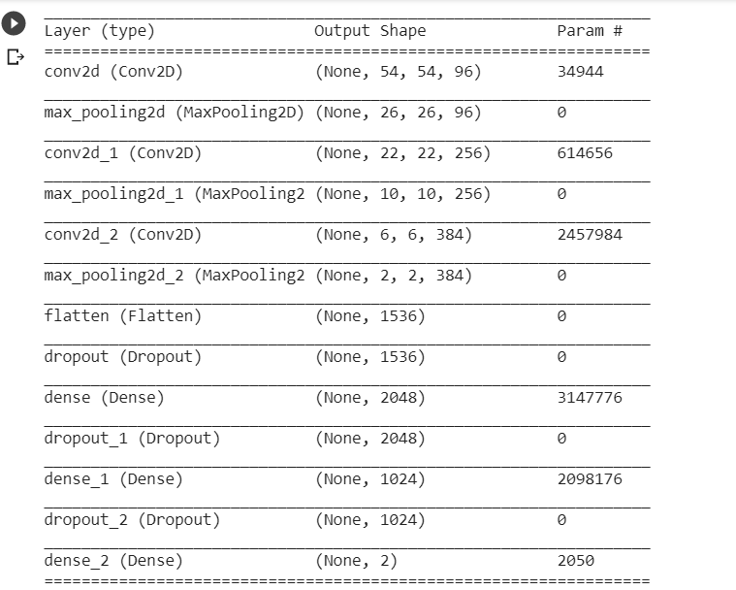

Fig 4.3.3.1(a&b) snap of the CNN phase and (b) the table of the various Layers

The Convolution Neural Network enables us to work with two-dimensional image data. It can be used for one as well as three-dimensional data as well.

Centre of CNN we have the **Convolution Layer** that deals with the multiplication of 2d array weight (filter /kernel) to the input data. The filter is smaller than the input layer and is basically the dot product of a 2d weight array to the input data. This helps us to detect a special feature in the input images. This is known as translation invariance i.e., can check whether a feature is present rather than where it is present.

**Pooling Layers** basically summarize as whether the feature is present in the feature map created by the convolution layer. They are of two types: Average pooling and MaxPooling2D layer. They tell us about the presence of a feature or the most dominant feature.

**Dense Layers** are strongly connected neural networks that means all neurons are connected to other neurons in the next layer. It helps us to learn features from the previous neurons and so on. The bias value (for optimization) is added to the dot product of input and kernel values. All these might cause a case of overfitting (high variance) thus we now require the use of dropout layers. They are used to drop the hidden layer or the network layer which is not required in the dataset and causing problems of overfitting.

After the creation of the CNN, we move ahead with the **Graphical representation** of the Training and Validation set in order to gain an understanding of whether the model is able to yield desired results. We see some issues in the efficiency of the prediction after training using the CNN model thus now, we move ahead to find a solution to increase the prediction accuracy. The detailed graphs and analysis are provided in chapter 5 of the model.

**4.3.4 CREATION OF THE INCEPTIONV3 MODEL**

As we see that the accuracy of the previous model was not satisfactory thus to increase the image accuracy, we decided to include the **Inception V3 Model.** This model is widely used for achieving an accuracy greater than 78.1% on ImageNet dataset. As we have incorporated the dataset from image net thus this model suits us.

We fetch the dataset again for the training and validation. Next, we Import the InceptionV3 model and all the layers (AveragePooling2D, Input, Dropout) as discussed in the previous units of the chapter.

Below is the snippet attached

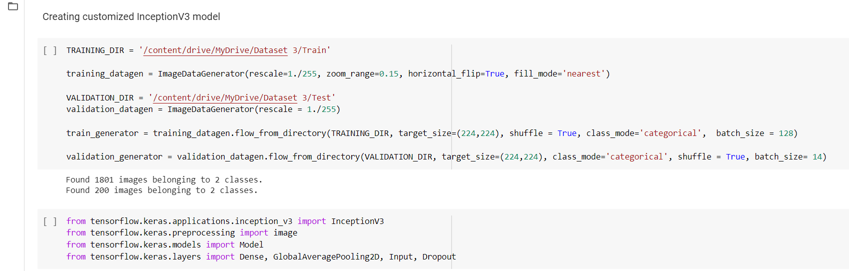

Fig 4.3.4.1 snap of importing the InceptionV3 model and other CNN layers

Now we move ahead to the **creation of the Model** along with the CNN layers First we define the **Shape** as a 224x224 matrix along with 3 RGB layers for our images.

Next, we define the weights as ImageNet as it has to be loaded there along with the inclusion of the include_top that is a boolean value that tells us whether to use the layer or not.

Next, we include the pooling and dense layer as discussed in the previous units. We have included here the concept of two Optimizers Relu and Softmax.

**ReLU** is basically a rectified linear activation function that gives the output to the corresponding input in the form of positive or negative values directly. It fulfils the shortcomings of the gradient and thus allows the model to learn faster and efficiently.

**Softmax i**s used to obtain one value as the result for every node of the neural network.

Below is the attached snap.

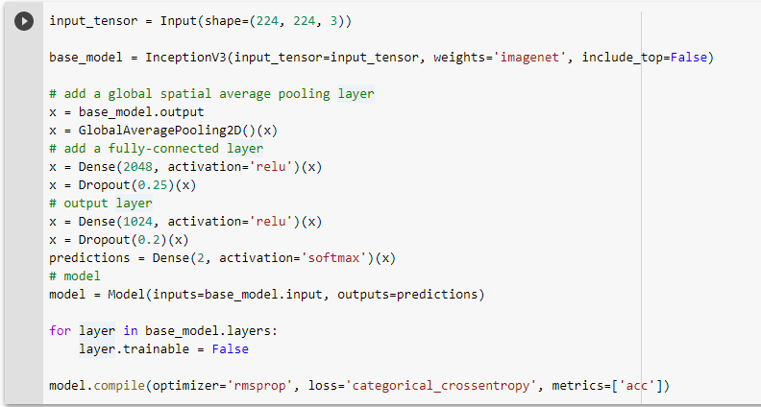

Fig4.3.4.2 snap of the creation of the models

Next, we callback the functions. It is a tool used in keras to control the behavior during training and evaluation.

Below is the attached snippet.

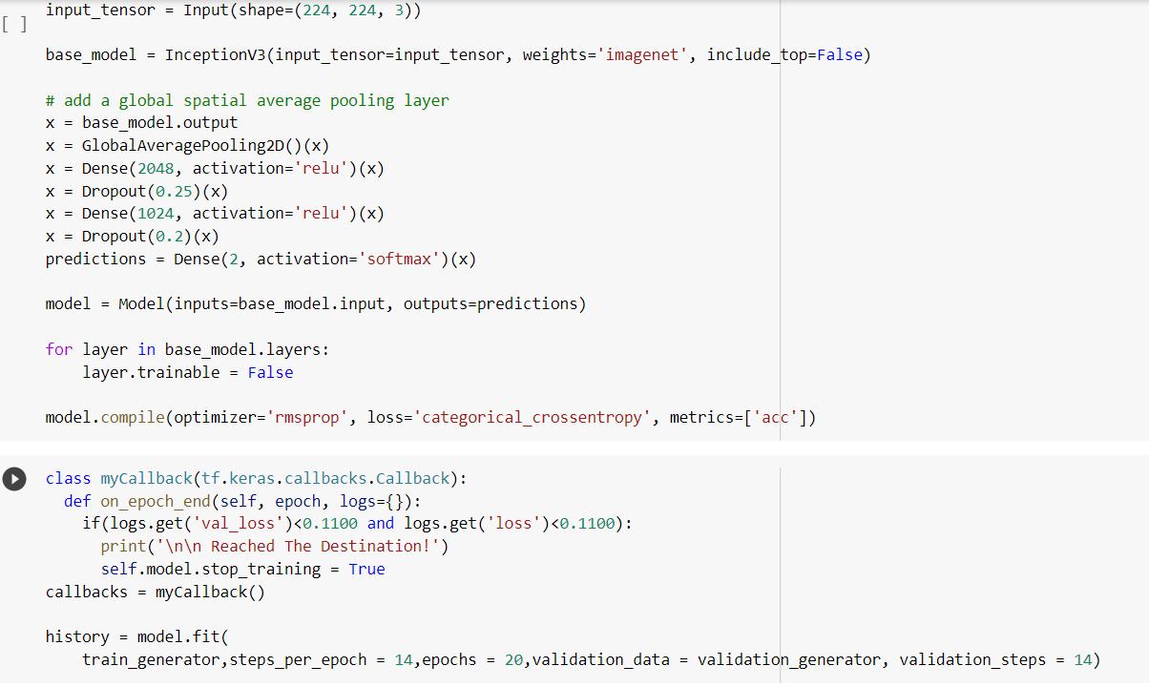

Fig4.3.4.3 snap of the call back function

(This is Optional just an experiment): Now we have an optional step, here we have just trained the model using a lesser number of images in order to compare the accuracy of the epoch cycle and we found that accuracy increased when the number of images were increased.

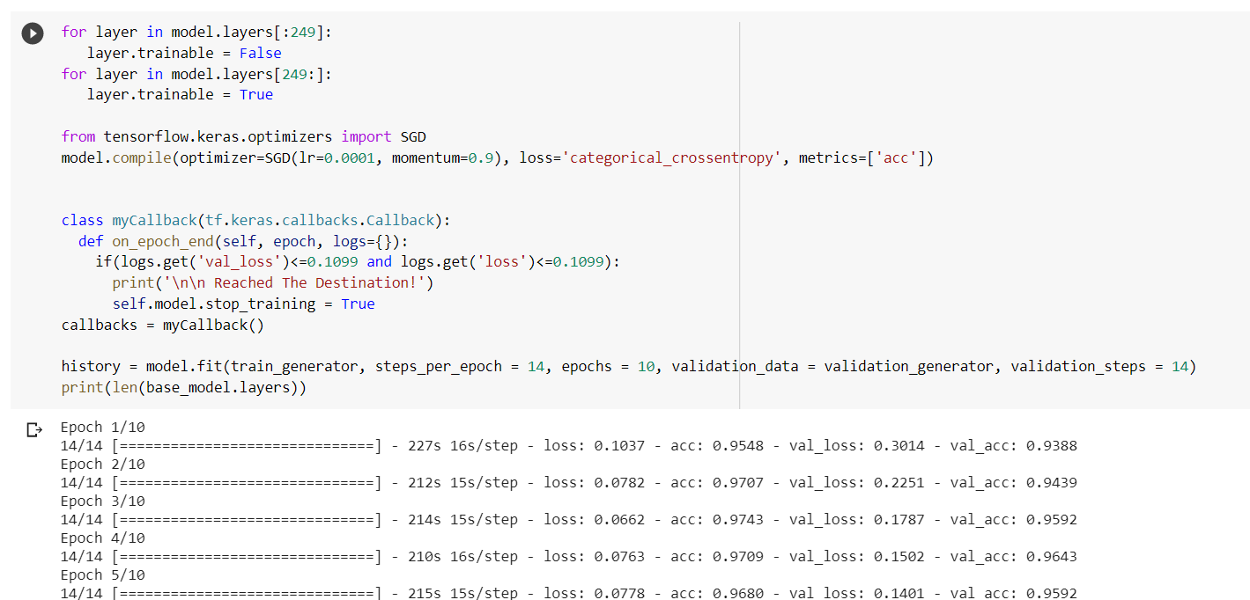

At last we move ahead with the TRAINING AND VALIDATION graph along with the comparative analysis of the results obtained earlier. All these are included in the next chapter.

We have also included a message sending system that warns the receiver of any mishappening in times of emergency. The snaps are attached below

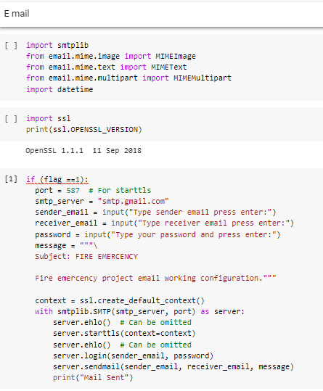

**CHAPTER 5: COMPARATIVE STUDY OF OBSERVATIONS**

**5.1 COMPARATIVE STUDY**

Below is a comparative analysis of the results of the two models CNN and Inceptionv3. Thus highlighting the need for the inclusion of the fourth module in chapter 4.

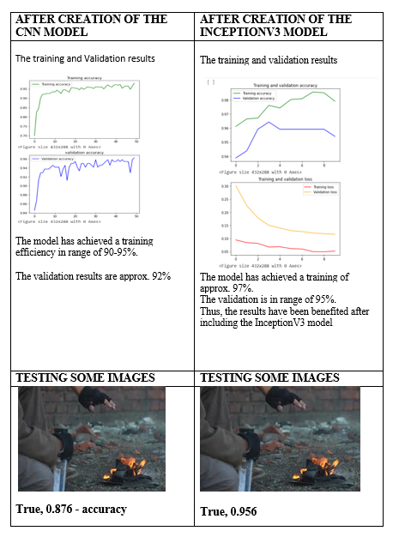

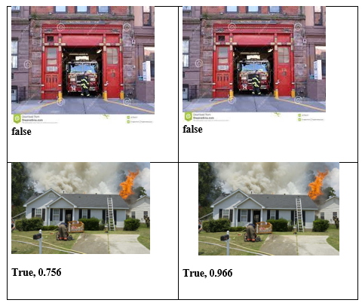

Table 5.1 comparative analysis of the two models

Thus, on comparing we see that after the InceptionV3 model the accuracy of the prediction has increased and the model is working in a more efficient manner. We tested the model on infrared images too and the predictions were 88% accurate. Thus, our model is giving us efficient desired results. The preview of the message received can be viewed below. Fig 5.1 snap of the message received.

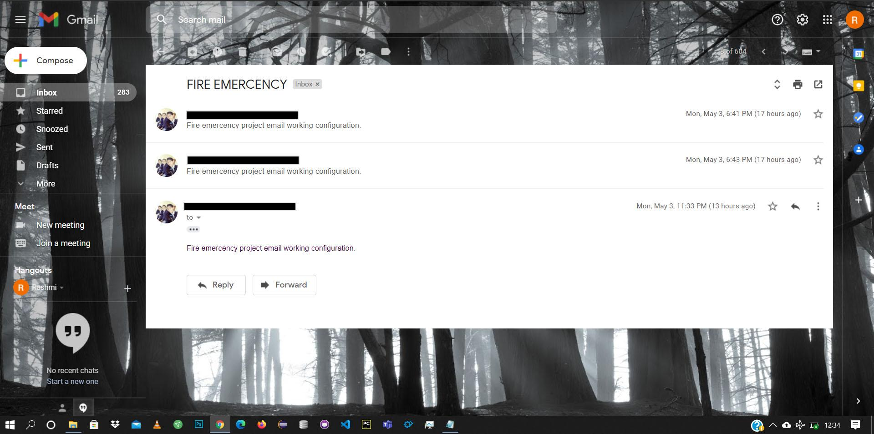

**CHAPTER 6 FUTURE WORK AND CONCLUSION**

**6.1 INTRODUCTION**

This work describes a proposal aimed at performing fire detection to reduce the accidents caused by fire. The system alerts the people by early detection of fire. The emergency services can be called at time and ultimately a big disaster can be averted.

**6.2 FUTURE SCOPE AND LIMITATIONS**

* RELIABLE FIRE DETECTORS

Development of reliable fire detectors designed to minimize the risk of false alarms. Because one of the biggest issues in fire detection is false alarms. In 2013, the emergency services responded to over 400,000 cases of false alarms which is clearly a waste of resources which diverts help from accidents of real need

* INTRODUCING SENSORS

In a similar way as lighting sensors react to a person’s presence in a room, development of fire detectors which detect not only the presence of heat, smoke and CO2, but also intelligently balance this against those present in the room, and evaluate the risks accordingly.

* ADVANCED DETECTORS

Development of more advanced detectors which can differentiate between steam and smoke. As false alarms are sometimes experienced in rooms where steam from hot showers can be interpreted by detectors as being smoke.

**6.3 CONCLUSION**

Fire is an unpredictable phenomenon that can pose a serious threat. If not detected on time, it can lead to loss of life and property. Fire accidents can be detected using cameras. So here we proposed a **CNN** approach and **INCEPTION V3** approach for fire detection using cameras. Our approach can identify the fire under the camera surveillance. We have obtained an accuracy of 75.6% using the CNN approach which is not a satisfying accuracy. To improve the performance of fire detection system, we shifted to another approach i.e., implementing the Inception v3 model to detect fire. This approach gave us an accuracy of **96.6%**. This value shows that the Inception V3 model gives a better prediction. We conducted experiments using datasets collected from ImageNet and verified it to our proposed system. In view of this model’s reasonable accuracy for fire detection, the system can be helpful to disaster management teams in controlling fire disasters in a short time. Thus, avoiding huge losses and proving an aid to mankind.

**REFERENCES**

1. [Ting Wei Hsu , Shreya Pare , Mahendra Singh Meena , Deepak Kumar Jain , Dong Lin Li, Amit Saxena, Mukesh Prasad, and Chin Teng Lin. An Early Flame Detection System Based on Image Block Threshold Selection Using Knowledge of Local and Global Feature Analysi](https://www.mdpi.com/2071-1050/12/21/8899/pdf)s, 2007
2. [Giuseppe Marbach, Markus Loepfe, Thomas Brupbacher](https://www.sciencedirect.com/science/article/abs/pii/S0379711206000142#!), [An image processing technique for fire detection in video images,](https://www.sciencedirect.com/science/article/abs/pii/S0379711206000142)[Volume 41, Issue 4](https://www.sciencedirect.com/science/journal/03797112/41/4)[, June 2006](https://www.sciencedirect.com/science/article/abs/pii/S0379711206000142)

# [Dongil Han, Byoungmoo Lee, Development of Early Tunnel Fire Detection Algorithm Using the Image Processing, 2006](https://www.sciencedirect.com/science/article/abs/pii/S0379711206000142)

# [TurgayÇelik, HasanDemirel](https://www.sciencedirect.com/science/article/abs/pii/S0379711208000568#!), [Fire detection in video sequences using a generic color model, Volume 44, Issue 2, February 2009](https://www.sciencedirect.com/science/article/abs/pii/S0379711206000142)

# [Paulo Vinicius Koerich Borges](https://ieeexplore.ieee.org/author/37546547800); [Ebroul Izquierdo](https://ieeexplore.ieee.org/author/38320860000), A Probabilistic Approach for Vision-Based Fire Detection in Videos, Volume 20, Issue 5, May 2010

1. <https://www.mdpi.com/2071-1050/12/21/8899/pdf>
2. <https://www.sciencedirect.com/science/article/abs/pii/S0379711206000142>
3. <https://link.springer.com/chapter/10.1007/11919629_5>
4. <https://www.sciencedirect.com/science/article/abs/pii/S0379711208000568#:~:text=The%20proposed%20algorithm%20uses%20YCbCr,other%20containing%20fire%2Dlike%20regions>.
5. <https://ieeexplore.ieee.org/document/5430942>
6. <https://towardsdatascience.com/early-fire-detection-system-using-deep-learning-and-opencv-6cb60260d54a>